Orator’s Report
on the 24th degree
Prince of the Tabernacle
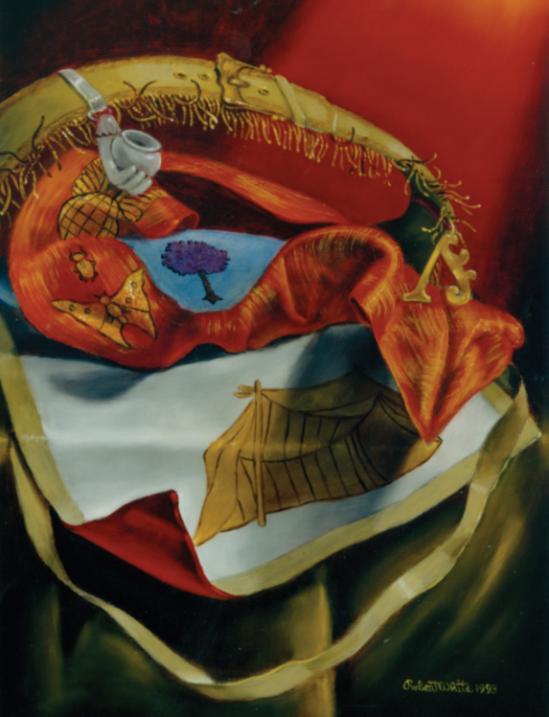
May 17, 2021
The apron is made of white lambskin, with a scarlet reverse and bordered in light green.

Bremerton Valley of the Scottish Rite

The Legend: The previous Degree presented the Lesser Mysteries almost exclusively as a Hebrew or Judaic tradition. The Mysteries were not confined to the Hebrews and here we find Deities from the most advanced cultures and countries of the past. We are now on the threshold of the Greater Mysteries.
The key to Pike's development of the the degrees of Scottish Rite Masonry lies herein with his study of the Ancient Myths or Mysteries of the world. Pike explores the similarity of the ancient Cycle of Life legends of Celtic Britons, Hindostan (India), Persia, Syria, Arabia, Phoenicia, Chaldaea (Babylonia), and Phrygian (Turkey) with that of the Hiramic Legend.
The Setting: There are two different apartments or decorations. The first is called the Hall and decorated like a Master Mason Lodge with the Samaritan (or ancient Hebrew) letter Yod hanging in the East instead of the letter G, but retaining the same meaning.
The decoration of the second apartment is virtually the same as in the 23rd Degree Tabernacle with the addition of the pentagram, with the Greek letters Alpha and Omega on it. The three parts of the tabernacle represented the earth, sea, and heaven; the twelve loaves of shewbread, the twelve months of the year. The candlestick represented the twelve signs through which the planets run their course; and the seven lights, those seven planets. The four colors: the four elements of the ancients air, earth, fire, and water. By aesthetic arrangement of the furniture is it is desired to express symmetry, harmony, and proportion.
The Ritual: The Lodge is styled 'The Court'. The presiding Officer sits in the East and is titled ‘Honored Leader’. On his right, is the Venerable High Priest. On his left sits the the Senior Excellent Priest. The Wardens sit in the West on the floor. All the Officers, except the Leader and Wardens wear turbans of white muslin and the apron and jewel of the Degree. The cordon is a broad, pale scarlet ribbon worn from right to left. On it are a beetle and butterfly as symbols of immortality. The Candidate (as Caleb in the 25th degree, KJV Numbers 13–14) is clothed in a white tunic without ornaments or insignia.
In the First Hall, the Candidate is subjected to four tests by officers stationed at the 4 points of the compass. He is then escorted to the second apartment where he is enlightened by the words of the various ancient myths reflecting the Cycle of Life. He is then styled as the Egyptian Osiris in a Hiramic allegory and is anointed as a Novice of the Mysteries.
The Lecture: This Degree illustrates the common features of some of the world’s major religions. The mystery religions of the past transmitted their teachings by symbol so that they could remain hidden to the uninitiated. The mysteries taught the doctrine of death and the resurrection; each bringing to this greatest of mysteries its own understanding of mode and significance. All the world's great religions have alike expressed the confidence that the true adherents of their faith could be recognized by the kind of life they led. Virtue has been the standard of righteousness from the beginning of time. The lessons of the Scottish Rite are taught by symbols because it is the most obvious mode of instruction. We teach those virtues which unite all men in a common purpose to make a better world through better action. Even in the ancient mysteries, as now in Masonry, it was not enough simply to be initiated; One has to accept the duties that come with such initiation. The objective of these duties is the improvement of the character of the individual.
The unity of thought that exists in all faiths, binding all mankind as one family, is the search for Divine Truth. The object of Masonry is social unity, by the alliance of Reason and Faith. However men may differ in their private beliefs, there can be but One True Origin of all Things. There can be but One True Creator. This fact alone makes all men Brothers.
To advance, the initiate must further study. To Know, to Will, to Dare, to Be Silent – these are fit rules of conduct for one who has attained or arrived at the knowledge of its practical application, a Master of Reason, and like the sun, a Master of the Regenerating Fire.

The lesson of this Degree is the universality of faith. The great Truths have been encoded into many myths and hidden in many allegories over time. As Albert Pike wrote (Morals and Dogma, p. 434): Our task is to understand those myths and allegories and to discover the Truths beneath them.
DUTIES: to work unceasingly for the glory of God, the honor of your country and the happiness of your brothers.
LESSONS: the power of Faith in Deity and its promises. The soul is immortal. There is one, true God who is pure, absolute intellect and existence.
FOR REFLECTION: Is the doctrine of soul immortality a comfort to you or a source of threat and despair or merely superstition?
IMPORTANT SYMBOLS: Touches of the Apprentice, Companion and Master Mason, the Five Pointed Star
The Cordon is a broad, pale scarlet worn from right to left. On the front a winged globe, a beetle, and a butterfly; all of them are symbols of immortality.
The girdle is light green leather edged with gold. From this belt hangs the Jewel of the preceding Degree, a silver incendiary and the Jewel of this Degree, the Phoenician letter Aleph.
The apron is made of white lambskin, with a scarlet reverse and bordered in light green. In the center is an Arabic tent in gold. .In On the light blue flap there is a violet Myrtle tree, an emblem of immortality.
The Jewel is the Phoenician letter A (Aleph), suspended from a short collar of narrow cord, pale violet in color. It is another manifestation of the pentagram, or five-pointed star, because the star, seen from any angle represents the letter A. As A is the initial of one of the main names of the Deity, Adonai, or Lord, this star is a symbol of intellectual omnipotence and autocracy.

Adapted from the Spanish version of Rex R. Hutchen’s book A Bridge to Light

